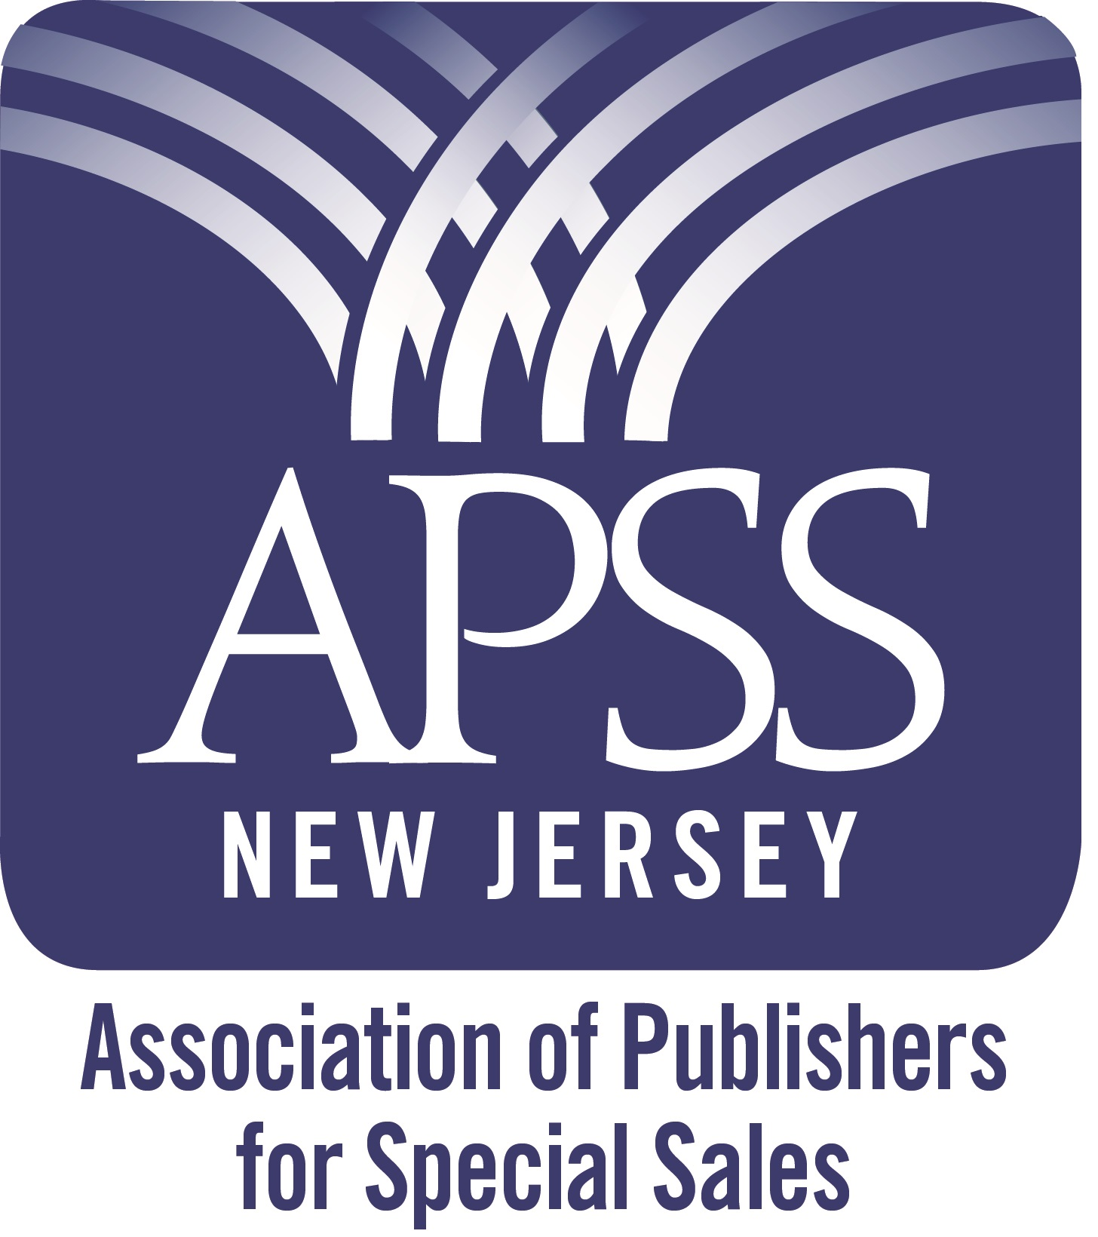

The 2016

Book Selling University

One day that can help you sell your books in large quantities with no returns

September 13 at the American Red Cross of North Jersey Region
209 Fairfield Road, Fairfield, NJ 07004

Book Selling University, Tuesday, September 13 (9:00 am – 5:00 pm). A content-heavy day of dynamic, practical, book-marketing information. Discover how you can become more profitable selling your books in ways that you never imagined and to people you never knew existed — in large, non-returnable quantities.

Attend this event and watch your sales, revenue and profits soar!

“Every independent publisher who is working to increase their sales must attend this conference.” Erika Liodice

“I recommend this program to anyone seeking to sell more books.” Laura Dobbins

Discover creative ways to increase your profitable sales.

Find out how to sell your books (not just books like yours) in large, non-returnable quantities to businesses, corporations, associations, schools, government agencies, the military and non-bookstore retailers.

Leave with a list of prospective buyers in the types of companies and organizations than can lead to long-term, recurring revenue

Discover practical book marketing tips and tactics that you can put into place immediately.

You will not sit back and just listen to us talk in general terms. We will get you involved and you will leave with ideas, prospective buyers and information you can use to sell more of your books more profitably.

To reserve your place at this session go to http://tinyurl.com/jjxyejb

Space is limited, so register today!

You will leave knowing:

- Why and how companies, associations, schools, government agencies and non-bookstore retail buyers could purchase your books – in most cases on a non-returnable basis

- A custom list of companies to approach as well as creative ideas for selling your books to them

- How to keep the pipeline filled over time with more non-bookstore buyers for your titles

- Innovative ways to present your recommendation to buyers and make large quantity, non-returnable sales

- Proven tips for negotiating profitable sales with specific hints that work for people who don't like selling

Early-Bird Special – Sign up by August 15, save $50 and get:
• A DVD loaded with 8 hours of book marketing information
• A copy of How to Make Real Money Selling Books (without worrying about returns), by Brian Jud

~~~ Bonus Follow-up Webinar for Attendees Only ~~~
You will get many marketing ideas. And after a few months of putting them into action, you are sure to have more questions. Approximately three months after our Book Selling University, Guy and Brian will host a free follow-up webinar. We can give you even more help by tweaking your strategies and offering alternative ideas. The webinars will be “live” so you will have the opportunity to ask your questions

For more information Contact: Brian Jud at BrianJud@bookapss.org (860) 675-1344

Be one of the 10 people to attend. Register today at http://tinyurl.com/jjxyejb

Agenda for the September 13

APSS – New Jersey Book Selling University

9:00 am Coffee, networking, visiting vendor tables

9:30 am Welcome, General Information, Kathy Miller, President, APSS-NJ

9:40am Session 1: Definitions and Types of Programs

Describe Target Consumers: Businesses, organizations, schools, associations, fundraisers, giveaways; how and why they may use books as promotional items

Types of programs: Gift with purchase, employee appreciation, incentives (sales, safety etc.), on-pack, near-pack, training; examples of each

10:30 am Session 2: How to Sell More Books with Facebook, Gene Sower
Facebook advertising can reach millions of like-minded readers. Learn how to target the correct audience on Facebook and drive traffic to your book offer.

11:30 am Session 3: Niche Publicity, Caryn Starr-Gates
Discover how to create promotional copy for advertising, marketing and public relations campaigns. Learn how to strategize PR angles and write, pitch, and distribute press releases; write ads, scripts, and jingles; and create collateral materials from brochures to posters to table tents. Caryn will also discuss online opportunities presented by social media outlets, such as blogs and social and business networking sites.

12:30 pm Lunch, networking, visiting vendor tables

1:30 pm Session 4: Who to Contact (Non-Retail), Guy Achtzehn
General prospecting strategy: Start small and local, then move regional and national; people to contact in each segment; demonstrate how to reach contacts online (local newspapers; Manta, Google, company websites)

2:30 pm Session 5: Who and How to Contact (Retail), Brian Jud
Demonstrate how to find buyers and contact people in each segment.

Describe mass-marketing efforts (letter campaigns, email blasts, trade show contacts; business referrals; donation programs; radio show giveaways; employee giveaways).

3:30 pm Session 6: Brainstorming Ideas for Selling Your Books, Guy & Brian
This popular session will demonstrate all the sales techniques described during the day. Get ideas for selling your books to buyers you probably never thought about contacting. Leave with a long list of new prospective buyers unique to your book.

Who are your coaches?
Two knowledgeable marketing pros will talk with you throughout they day. Together Brian Jud and Guy Achtzehn have sold over 5,000,000 of clients’ books. Guy Achtzehn has built a business as an innovative marketer of promotional products.

Guy Achtzehn

Guy is the president of the Promotional Bookstore and founder of the Marketing and Sales Group, a company he formed over 20 years ago selling products as premiums, incentives and ad specialties to buyers in corporations, small businesses, associations, schools, government agencies, hospitals and other prospective buyers. He has represented Simon & Schuster and Random House titles.
“Not only is Guy incredible at sales, he's amazing at teaching sales. By the end of our ten hours together, I had already made my first deal, which was worth more than the consulting fees I paid to work with Guy. He is full of ideas and it was so much fun to hear how he thinks. My mind was really opened to the many opportunities in the B2B market, and I am moving forward with more opportunities. It's not even a question that it's worth the money to work with Guy - if you implement, you will end up making a lot more than you initially spend!”

Karen Kilpatrick, Nina Charles LLC

Brian Jud

Brian is the Executive Director of the Association of Publishers for Special Sales (APSS). He is also an author, book-marketing consultant, seminar leader, television host and President of Premium Book Company that sells books to non-bookstore buyers on a non-returnable, commission basis.
Brian is the author of How to Make Real Money Selling Books (Without Worrying about Returns) and Beyond the Bookstore - a Publishers Weekly® book), a primer on non-bookstore marketing. He has written and published five titles on career transition that are distributed internationally, and is the author of the eight ebooklets with Proven Tips for Publishing Success. And Brian is creator of the series of Book Marketing Wizards and editor of the bi-weekly newsletter, Book Marketing Matters. Brian conducts semi-monthly book marketing webinars and is a speaker in the series of Masters of Marketing seminars held in cities around North America.

Gene R. Sower

Gene R. Sower is the owner of Samson Media, LLC, an Internet marketing company specializing in content marketing, website development, and generating search engine traffic for small and medium-sized companies. Gene is a longtime resident of Montclair, New Jersey, where he lives with his wife Nina and two Jack Russell Terriers. Gene proudly named Samson Media after his son Samson, who graduated from the U.S. Air Force Academy and is a 1st Lieutenant in the U.S. Air Force.

Caryn Starr-Gates
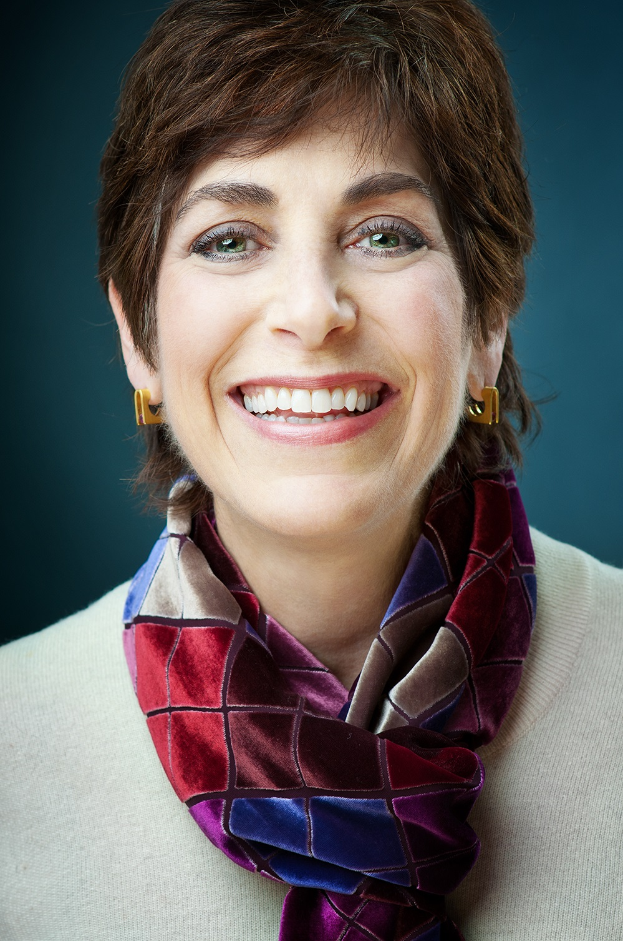
Caryn Starr-Gates is a professional copywriter working in advertising, marketing and public relations. She writes for all media—print, broadcast, and digital—for a broad range of clients across many industries, for consumer and B2B accounts. Caryn launched StarrGates Business Communications in 2009; she and her team create promotional copy for ads (print, radio, TV, online), marketing materials, newsletters, articles/blog posts, press releases, websites, email marketing, and social media content as well as new product concepts. Her clients are small businesses, solo-preneurs, and boutique as well as larger agencies (digital and full-service marketing, public relations, advertising) and their clients.

Registration Fees

One-day University paid by August 15: $69* ($49 for APSS Members)

* Fee for Non-APSS members but you can join APSS on September 13 for only $30 additional

All fees increase $50 if paid after August 15 (if space is still available)

The first ten people to register will receive a copy of Brian Jud’s book, How to Make Real Money Selling Books (without worrying about returns) and a CD-ROM with eight hours of special-sales information

Register now at http://tinyurl.com/jjxyejb

For more information contact: BrianJud@bookapss.org

Refund Policy: APSS will refund 50% of eligible payments until September 1. No refunds after September 1

Why Should You Attend?

There are many conferences that tell you how to sell (returnable) books to bookstores and how to stand out by using Twitter and Facebook. Well, we intend to show you how to sell your books by the trainload. More than half of all books sales are made to non-bookstore buyers. You will discover how to find those markets and sell your books to them in large, non-returnable quantities. You can double your book sales profitably simply by doing what you learn at this APSS-New Jersey event.

Invest in your future. One idea could turn your investment into a thriving, profitable business

“Excellent. Well worth the investment.” Jim Riviello

“Lots of relevant, timely and specific information for writers and publishers. Very empowering!” Ruth Crocker

Meet with other like-minded people who are willing to invest in their future—you will be among the cream of the crop of serious, independent publishers and authors: people willing to share information for mutual support

“…. an intense, dynamic and fascinating event. I acquired an enormous amount of valuable information and made great contacts!”
Jan Kardys

Attendees are the people who “get it”. They know that if their business is going to be successful, it’s up to them to create, find and implement savvy marketing strategies to make their book sales soar

Networking rocks! Starting relationships with people who have similar goals will benefit you well into the future. This event will be a productive way to socialize. There is free time for you to mingle with the speakers, exhibitors and other attendees.
“I learned enough new things, got enough new ideas and connected with enough great people to easily justify the time and cost of attendance.” Gail Woodard

Talk with the speakers and discover new ways to sell your particular book – not just books like yours.

“I was so impressed with the speakers and content, and I left feeling inspired and excited about the knowledge I gained and the new contacts I made.”
Erika Liodice

Active learning is more motivational. You are more likely to implement the ideas you hear—the personal interaction compels you to action with a greater likelihood of positive results

Ask your questions while the topic is being discussed. You also can learn from the questions of others – many times on topics you wouldn’t think to ask.

This event is "content-heavy" with personal interaction for information customized to your books.

“ … I now have some immediate actions.” Kim Catalano

There will be a large quantity of information on a variety of interconnected topics. You will learn from experienced and successful professionals whose interrelated content can help you exponentially.
“A hands-down must for authors determined to make money from their book and for independent publishers wanting to expand their business.” Laura Larson

For More Information Contact:
Brian Jud, Executive Director - APSS
BrianJud@bookapss.org
(860) 675-1344

Kathy Miller
President, APSS – New Jersey
Kathy@bookapss.org

Click Here Now to Register

“The APSS conference delivered good content and accomplished bringing people together to build relationships that will last them for years to come. I know it has for me!” Larry DeKay

“ Now if our heads do not explode with knowledge we can put a few things into practice.” Nadine Yawn

“… truly a very worthwhile event.” Tana Thompson

